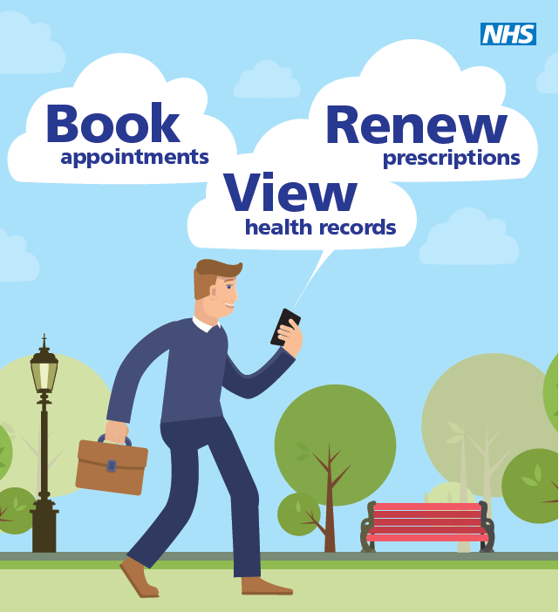

Patient Online Services
The following leaflet tells you:
- What online services the practice currently offers patients
- Who can access these services
- Important considerations before requesting these services
- How to register to access online services

QUAYSIDE MEDICAL PRACTICE

What are Patient Online Services?
Patient Online services have been developed to help patients take greater control of their health and wellbeing and can be more convenient for some patients to use instead of contacting the Practice. Online services include:
- Booking appointments online
- Ordering repeat prescriptions for medications taken regularly
- Viewing detailed information from medical records

Making sure everybody is included
We recognise that not everyone is as comfortable using computers as others, but may still wish to have the benefits of using the Patient Online Services.
There are lots of places where you can learn how to use the internet. A good place to start is your local library, but there are many others where you can learn for free, such as:
- UK online centres help people learn how to use the internet and manage their health online. Visit www.learnmyway.com or phone 0800 77 1234.
- Age UK helps older people get online. For more information please go to www.ageuk.org.uk or phone 0800 169 6565.

Is it secure?
You will be given secure login details once your application has been processed. This will ensure that only you are able to access your record – unless you choose to share your details with a family member or carer.
Your Responsibilities
- Keep your login details and password safe and secure;
- It will be your responsibility to keep your login details and password safe and secure. If you know or suspect that your record has been accessed by someone that you have not agreed should see it, you should change your password immediately.
- Keep any information you print out from your record secure. If you are at all worried about keeping printed copies safe, we recommend that they do not make copies at all.

Need further information about Online Services?
A short online course on how to use Patient Online Services is available at: www.learnmyway.com/what-next/health.
For further information about Patient Online Services you may find the the following websites useful:
- NHS Choices (www.nhs.uk) and search for Patient Online
- NHS England (www.england.nhs.uk) and search Patient Online

How can I register for Online Services?
Registration forms are available at Reception or can be downloaded from our website: www.quaysidemedicalpractice.nhs.uk.
Patients must complete the Online Access application form and return it to Reception. Photo ID and proof of address must be provided at the time of application to confirm your identity.

If you do not have any ID and are well known to the practice, a member of staff may be able to confirm your identity.

If you do not have any ID and are not well known to the practice, we may ask you questions about the information in your GP record to confirm the record is really yours.

Once we have received your application form, your request will be reviewed by the GP. You will be informed whether access to these services has been authorised and will be asked to collect a letter with your unique activation codes and instructions on how to set up your online service account. The practice asks patients to collect this from the surgery so that we can confirm you have received this.
If access to these services is denied, you will be informed of this, as well as the reason for the decision.
How can I cancel my online services?
If you no longer wish to use the Online Services, please contact the practice who will be able to withdraw your access to these services.

If you require further clarification, please contact the practice for a clearer explanation.

For more information about keeping your healthcare records safe and secure, you will find a helpful leaflet produced by NHS England:
www.england.nhs.uk/wp-content/uploads/2015/11/po-protecting-your-gp-records.pdf

Considerations before accessing Online Services

Before you register to access online services, there are things that should be considered first, particularly in relation to accessing medical records:

Booking appointments online:
A proportion of our appointments for GPs have been allocated for online bookings. These appointments will be released as per our usual appointment protocol, i.e. patients will be able to book up to two weeks in advance.
Nurse appointments are not currently available to book online due to various different time slots required for certain procedures.

Ordering repeat prescriptions for medications taken regularly:
This service is available to those who already have regular, repeat medication prescribed.
Patients are asked to maintain the usual notice period for prescription requests (i.e. 2 working days’ notice, or 3 working days for pharmacy collection).

Viewing detailed information from medical records:
- Access: A GP will review your record before allowing access online. There may be circumstances where a GP may not think it is in your best interest for you to look at your records online or to share all of the information in your record. In particular, there may be circumstances where it is likely to cause serious harm to your physical or mental health, or condition, or any other person, in which case the GP would withhold that information. If this happens, the GP will discuss their reasons for their decision with you.
Coercion: If you feel you may be pressured into revealing your login details or revealing details from your medical record to someone against your will, it is best that you do not register for access at this time. If someone is pressurising you to show your record to them, you can talk to your GP about this. If you become worried about this in the future, you can have your access removed at any time.
If staff at the Practice are worried that you may be coerced to reveal your data, they can withdraw access as a temporary safety measure. If this happens, please talk to a member of the practice team about reinstating that access if the safety issues have been resolved.

Sharing your information: It is for you to decide whether or not you share your information with others - perhaps with family members or carers? It is your choice, but also your responsibility to keep the information safe and secure.

Forgotten history: There may be something you have forgotten about in your record that you may find upsetting.

Abnormal tests: If you are given access to test results, you may see something that you find upsetting, or do not understand. This may occur before you have spoken to a doctor or while the surgery is closed and you cannot contact them.

Information about someone else: There may be circumstances where information relates to, or is provided by, a third person who can be identified from the information and has not consented to its disclosure. The GP will consider whether it is reasonable to disclose the information without their consent.
Sometimes, however careful we are, information can occasionally be filed in the wrong person’s notes by mistake. If you spot something in the record that is not about you and you were not already aware of it, or you notice any other errors, please log out of the system immediately and contact the practice as soon as possible so we can review it.

Misunderstood information: Your medical record is designed to be used by clinical professionals and therefore some information may be highly technical, written by specialists and not easily understood.

Can I access Online Services on someone’s behalf?

Proxy Access:
Patients may choose to share their login details informally with family, friends and carers, however, this is not recommended by the Practice. Patients who choose to share their login details informally should be aware that there will be no audit trail of access to their record by their proxy. It will not be clear who has been accessing the record online. The proxy will have the same access to the record as the patient.
People aged 16 or above are assumed to be competent unless there is an indication that they are not. Legitimate reasons for the Practice to authorise proxy access without a patient’s consent include:
The patient has been assessed as lacking capacity to make a decision on granting proxy access and…
- has registered the applicant as a lasting power of attorney for health and welfare with the Office of the Public Guardian; or
- the applicant is acting as a Court Appointed Deputy on behalf of the patient; or
- in accordance with the Mental Capacity Act 2005 code of practice, the GP considers it in the patient’s best interests to grant the requested access
The GP will review requests for Proxy access on an individual basis. Proxy access will not be granted / will be withdrawn if:
- The patient has previously expressed a wish that if they lose capacity, proxy access should not be granted to the individual;
- It is not in the best interest of the patient;
- A GP or other health professional suspects that the patient is vulnerable to or already subject to coercion;
Children’s Access to Online Services:
- It is Practice policy that online access is not available to detailed coded records for children under 16 years of age.
- Persons holding parental responsibility for children under 16 years of age may apply for on line access to our appointment and repeat prescription services.
- This access will automatically be withdrawn when the child reaches 16 years. All patients attaining the age of 16 years will therefore be required to apply for access for this service to be continued.

